ASSIGNMENT 02 AYUSH CHOUGULE 02 1032231720 :
Implementation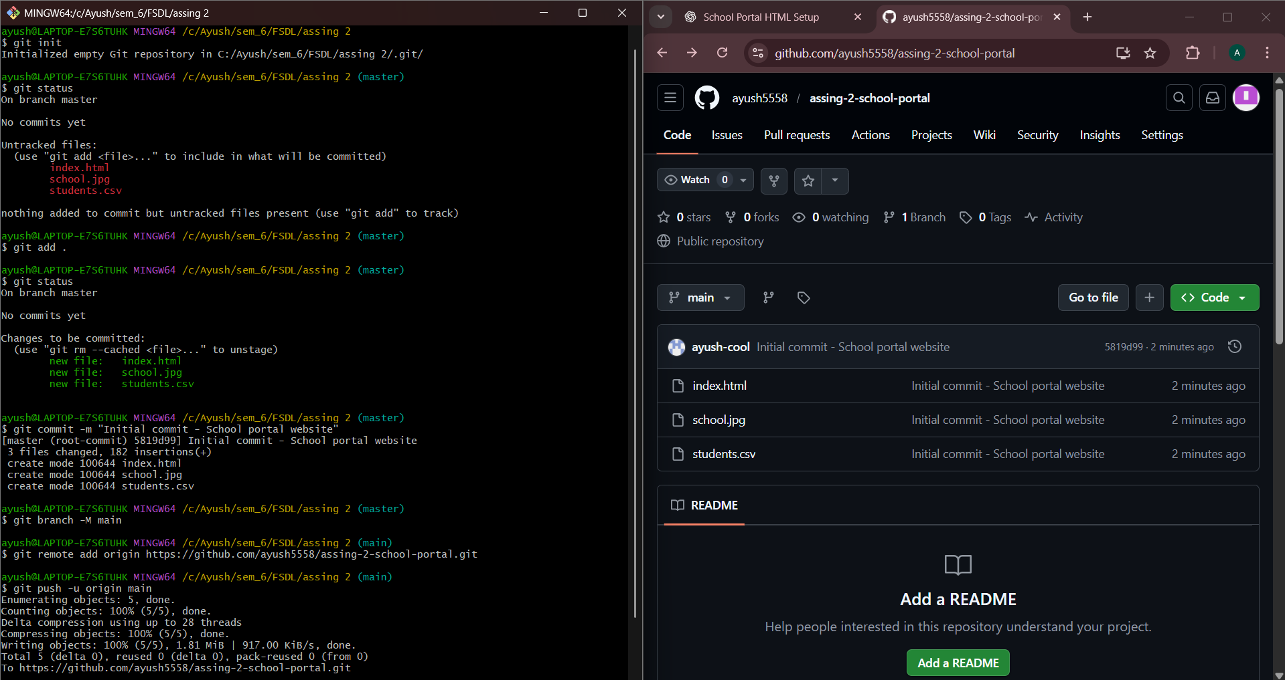
WEBSITE:
